* + 1. **S3 Website Overview:**

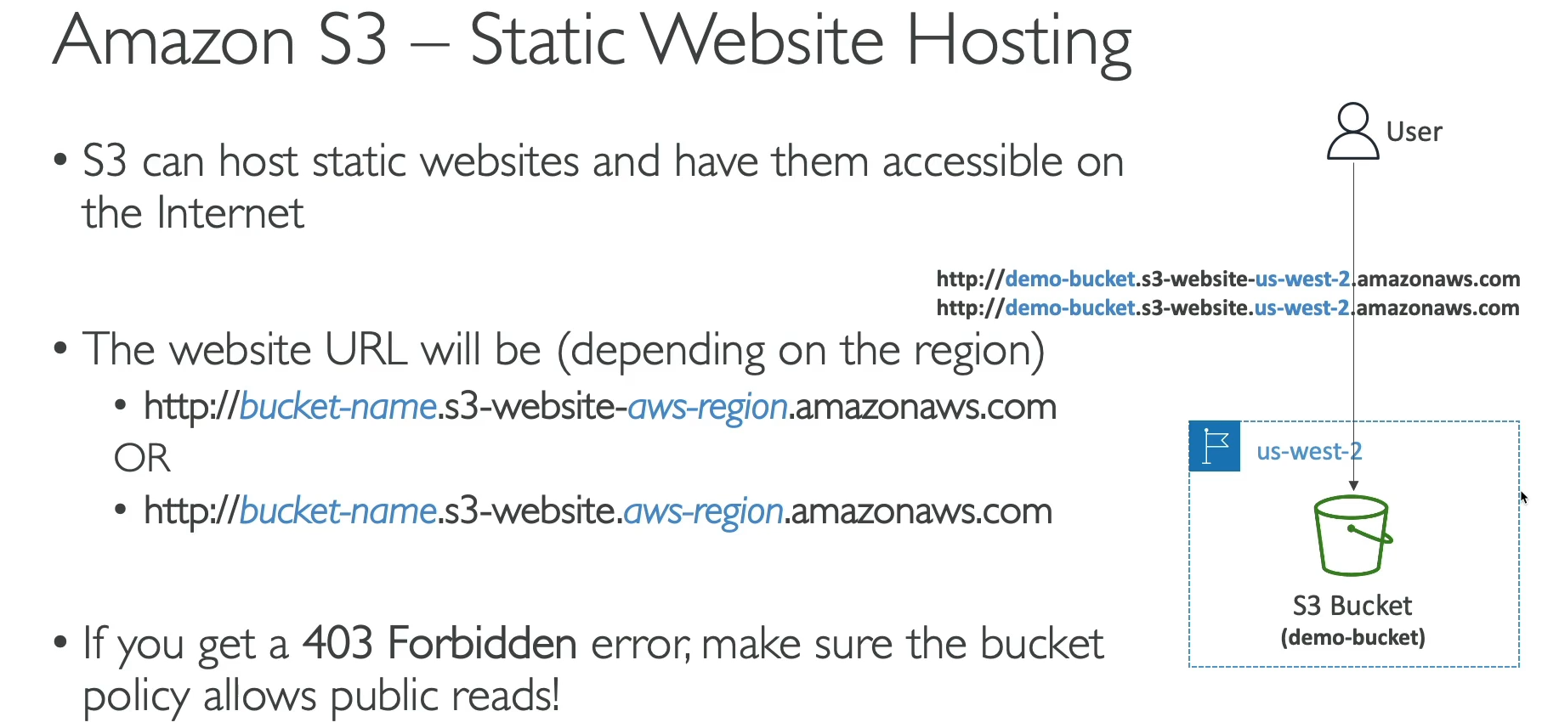

Amazon S3 can be used to host a static website. A static website consists of content that doesn't change based on user interaction, like HTML, CSS, JavaScript, images, and other client-side files.

* **Hosting Capabilities:** S3 has a built-in feature to host static websites. Once enabled on a bucket, it generates a unique public URL for the website, which can be shared with users.
* **Static Content:** S3 is ideal for hosting static content because it is a file-based storage service. You simply upload your website files (e.g., index.html, styles.css) to an S3 bucket.
* **Access Control:** For a hosted website to be viewable by the public, the S3 bucket must have **public read access** enabled. This is accomplished by creating an **S3 Bucket Policy** that explicitly allows public access to the bucket's objects.
* **Troubleshooting:** A common error when setting up an S3 static website is a "403 Forbidden" error. This error indicates that the bucket is not publicly accessible. The solution is to add or correct the bucket policy to grant public read permissions.
* **Website URLs:** The URL for the static website is based on the bucket name and the AWS region where it's hosted. The format is typically http://<bucket-name>.s3-website-<region>.amazonaws.com. While the exact format may vary slightly, it remains consistent within a region.

1. **S3 Website Hands On:**

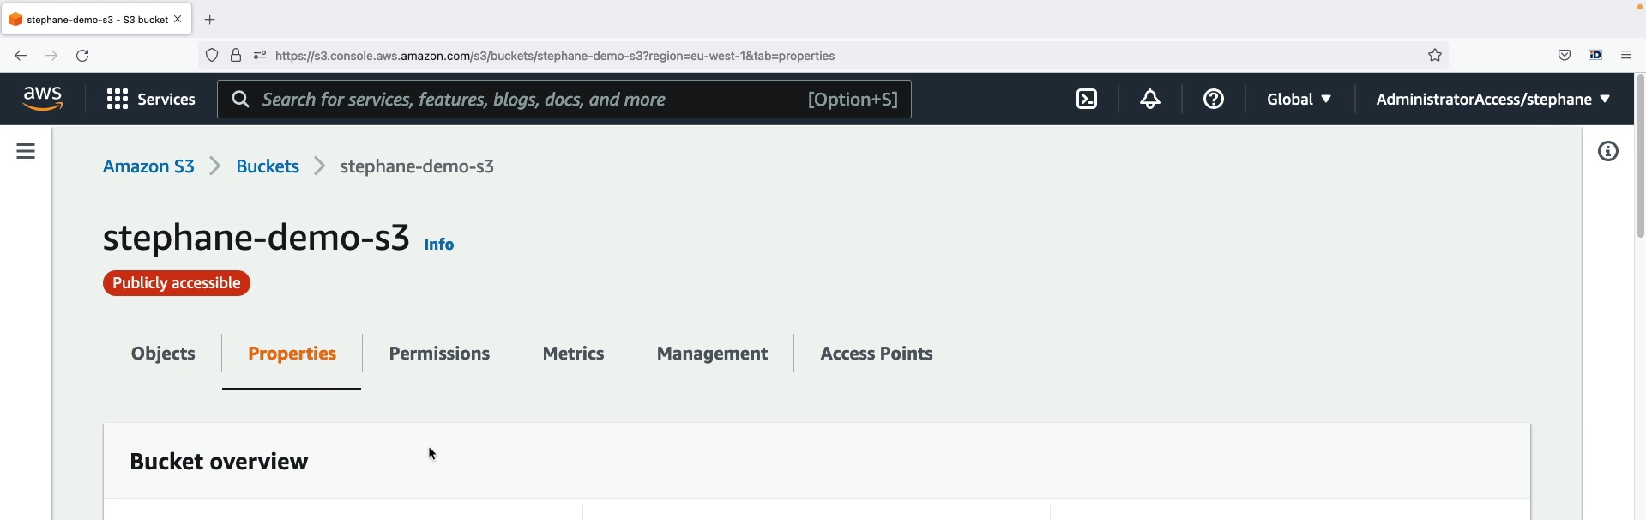

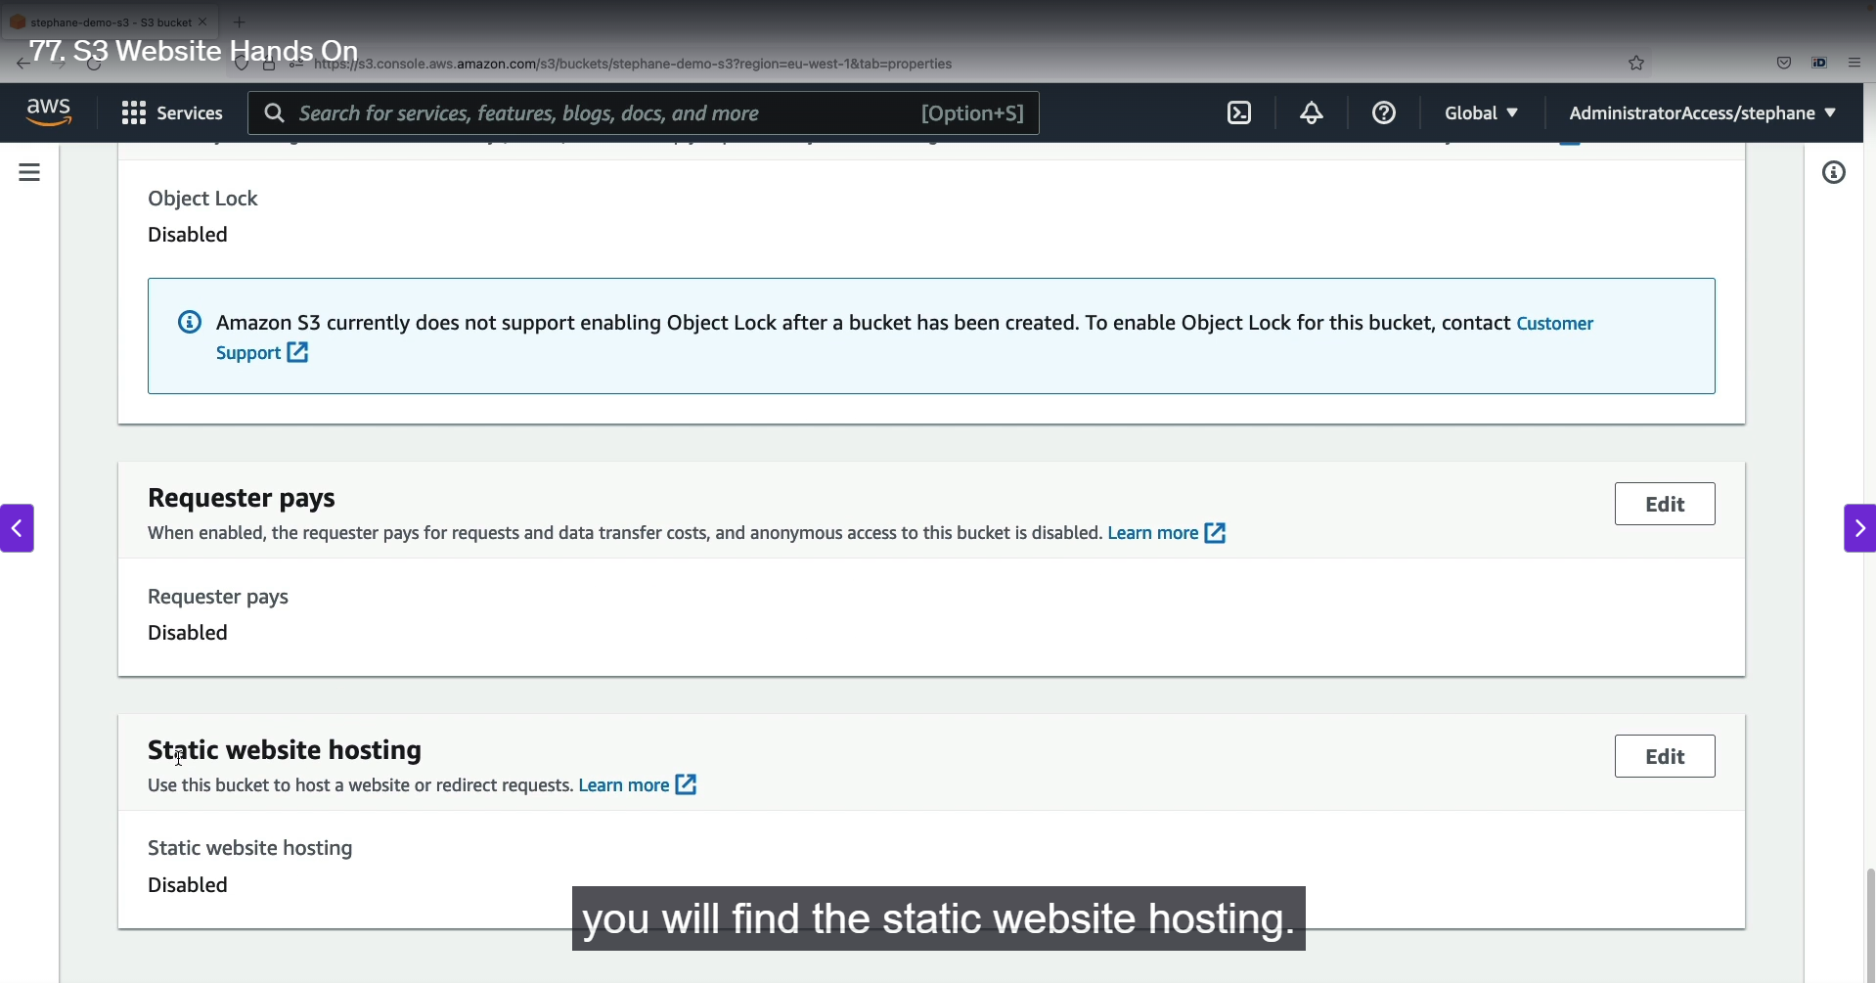

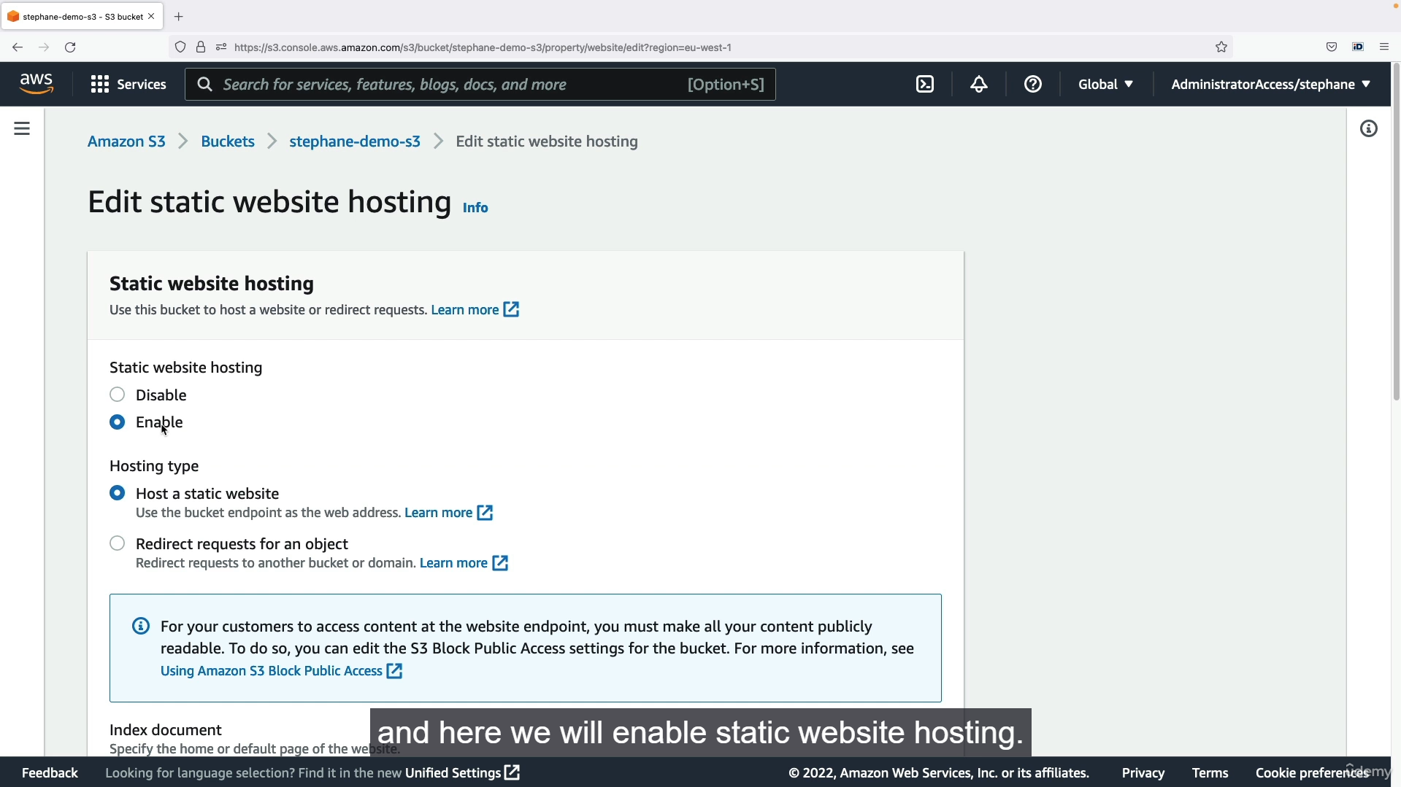

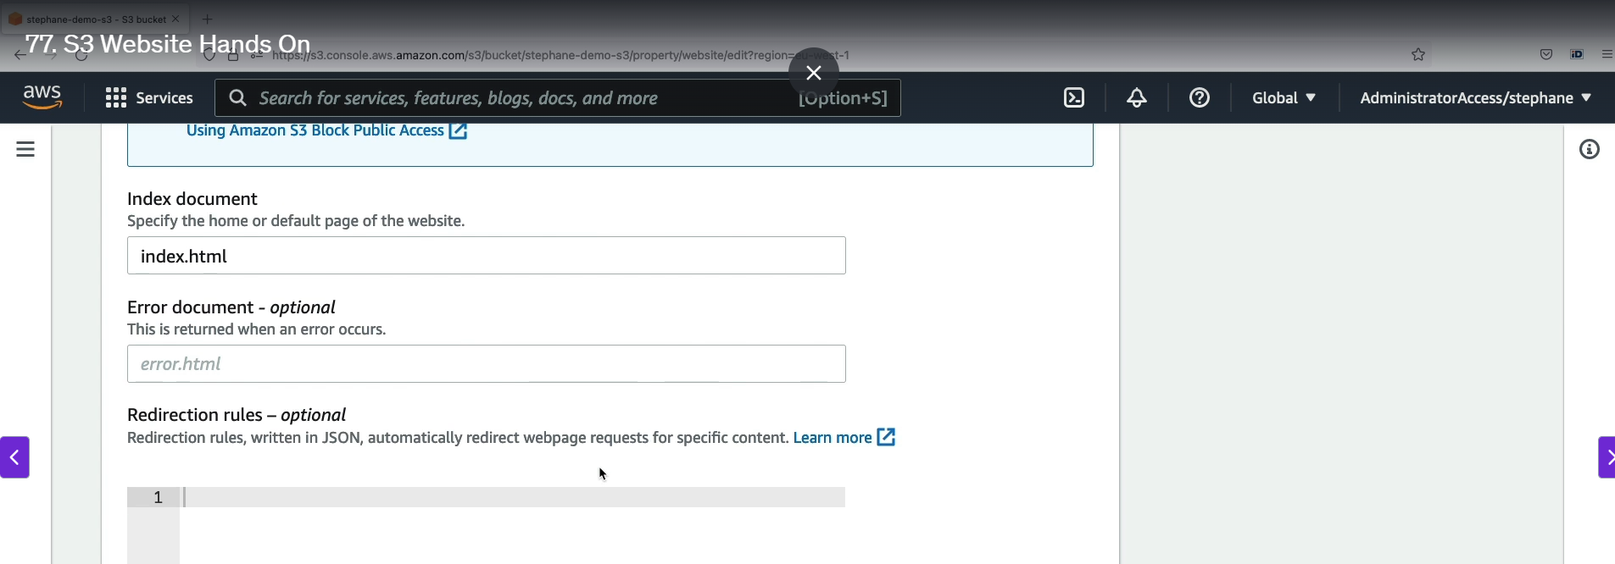

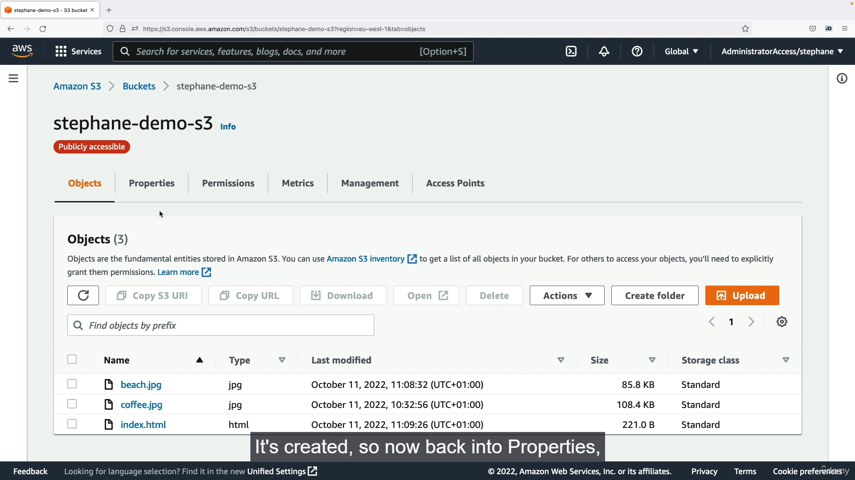

Step1 : Enter bucket setting 🡪 properties 🡪 down static website hosting 🡪 Edit 🡪 enable 🡪 Enter the name of the home page of your static website 🡪 here it is index.html.

Step2: Click save changes 🡪 make sure the main home page file uploaded in the s3 bucket.

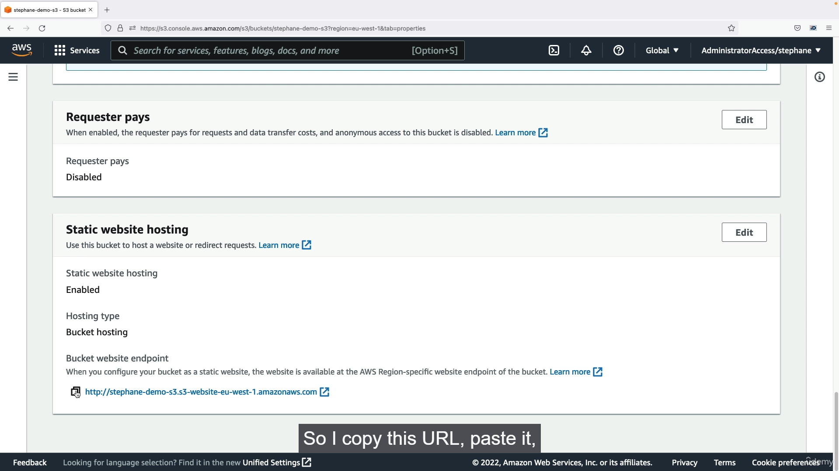

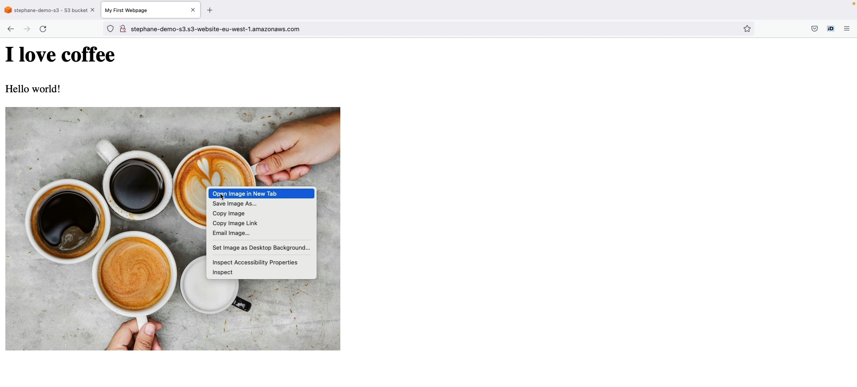

Step1 : Again go to properties 🡪 down static web site hosting 🡪 there will be website link 🡪 copy link 🡪 paste in browser 🡪 website home page will appear 🡪 because we can public access to that bucket.

Step2: If any issues or facing 403 forbidden error means 🡪 it is related to bucket policy 🡪 So make sure you entered the correct bucket policy in JSON format.

1. **S3 Versioning Overview:**

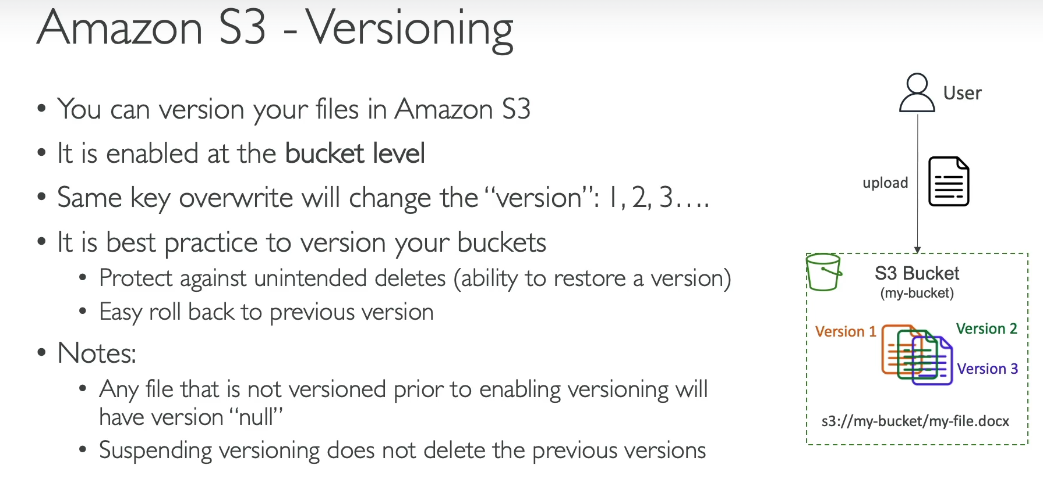

S3 Versioning is a feature that allows you to keep multiple versions of an object in the same bucket. It's a key safety and data management tool for S3.

How It Works

* Bucket-Level Setting: Versioning must be enabled at the bucket level. It's not turned on by default.
* Version IDs: Once enabled, every time you upload or modify a file with the same key, S3 creates a new version of the object with a unique version ID. This means all previous versions are preserved, not overwritten.
* Versioning before Enabling: Any objects that were in the bucket *before* versioning was enabled will be given a null version ID.
* Suspending Versioning: If you later suspend versioning, it will not delete any existing versions. New uploads will simply not create new versions.

Key Benefits

* Data Protection: Versioning protects against accidental or unintended deletes. Instead of permanently deleting an object, S3 places a delete marker. You can easily restore the previous version by deleting this marker.
* Easy Rollback: You can quickly and easily roll back to an older version of a file. This is useful for recovering from bad edits or unwanted changes.
* Safety: The versioning feature is a crucial part of a robust data management strategy, ensuring that you have a history of your files and can recover from mistakes.

1. **S3 Versioning Hands On:**

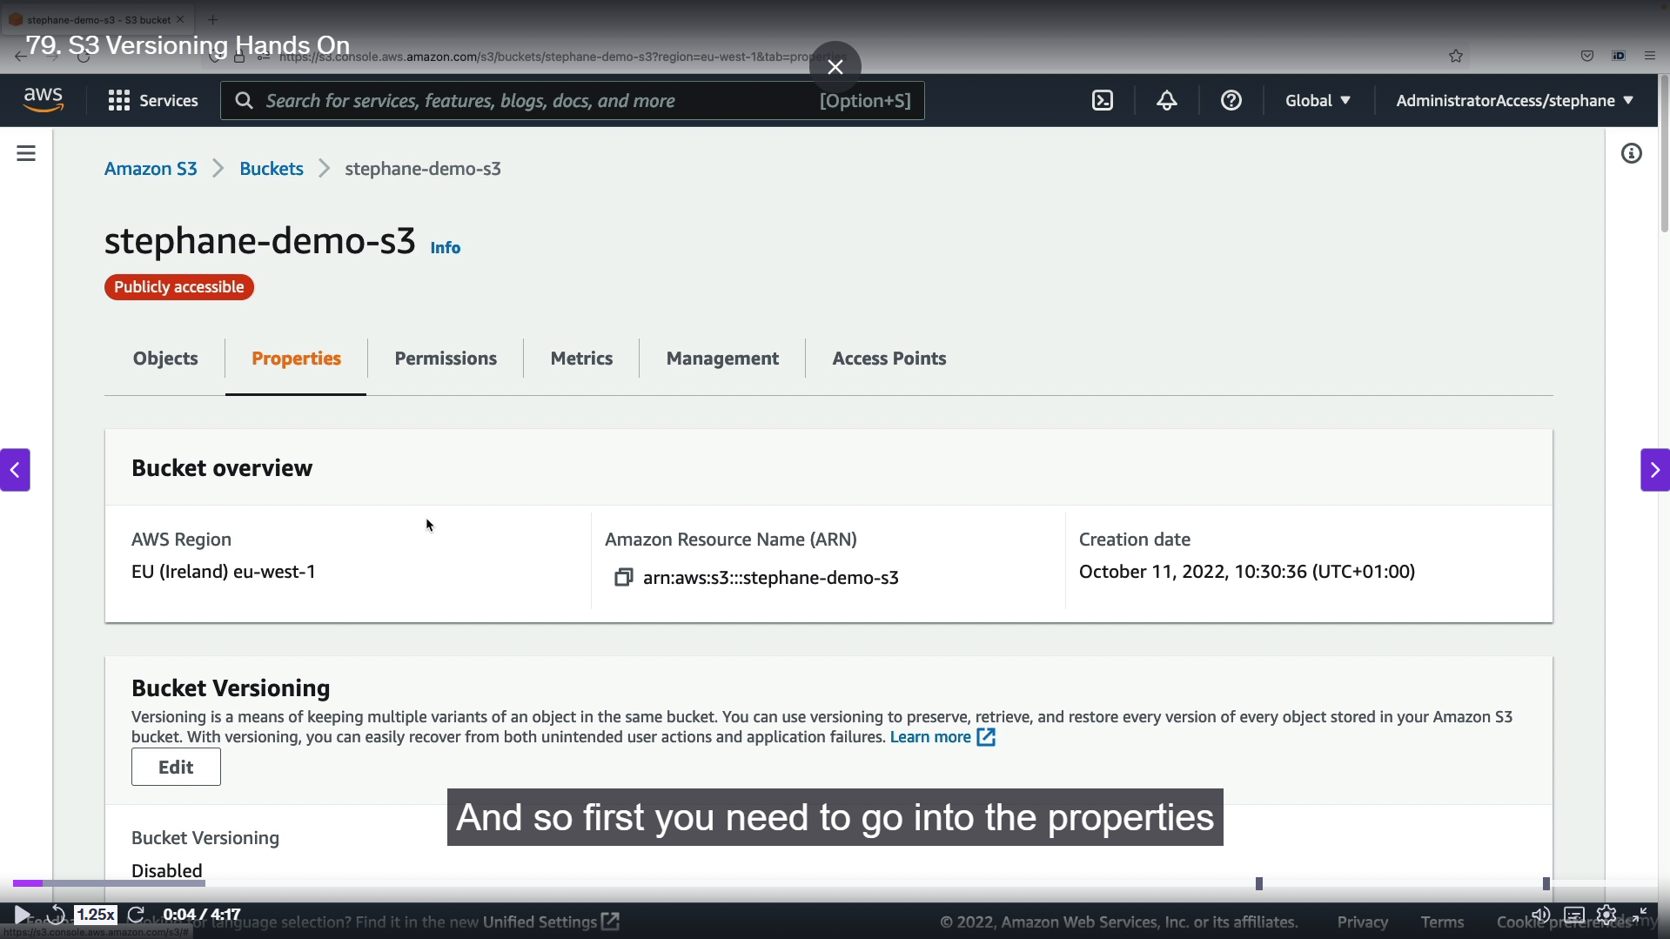

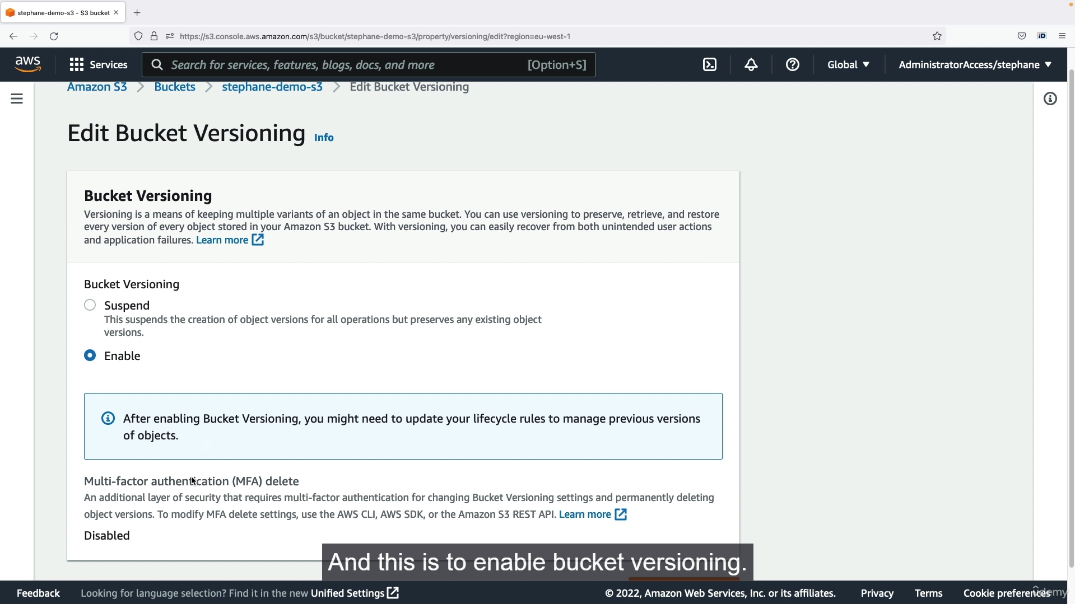

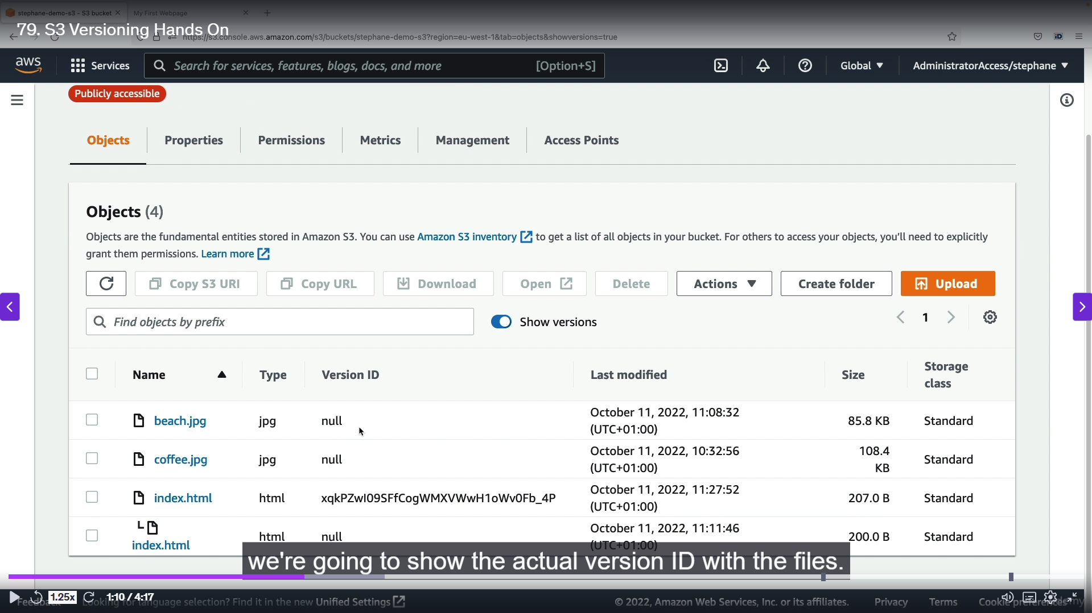

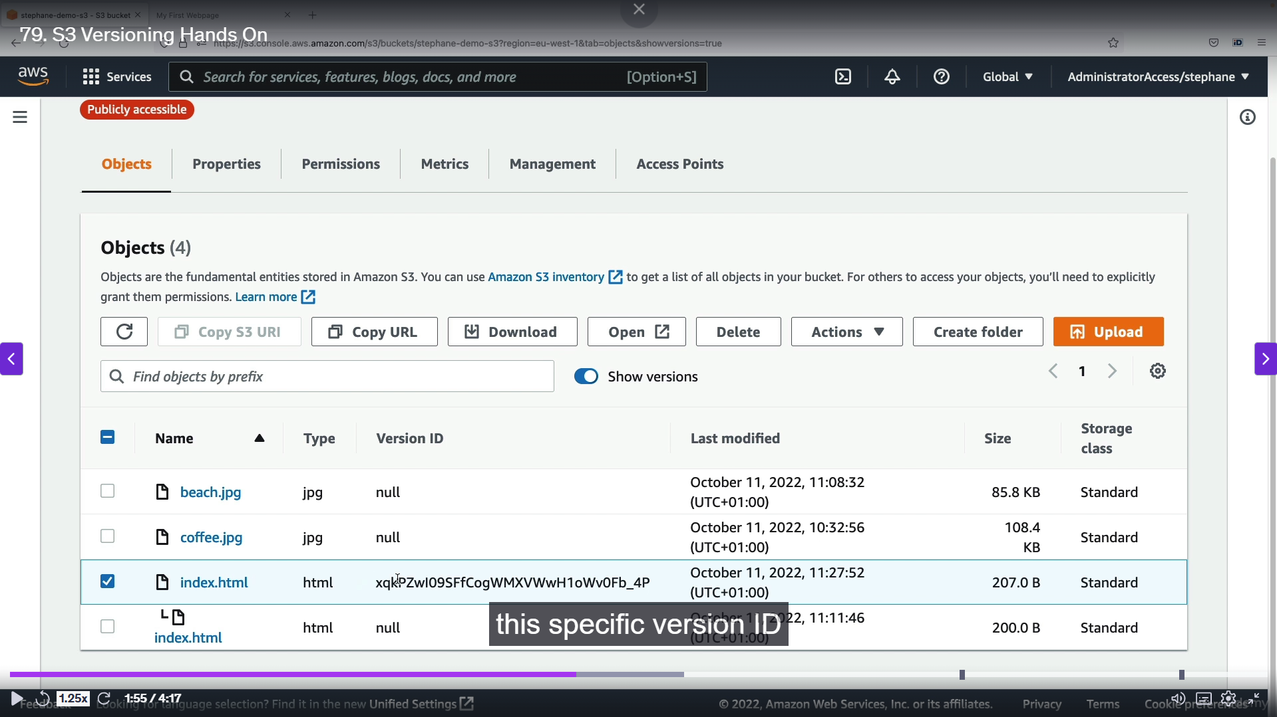

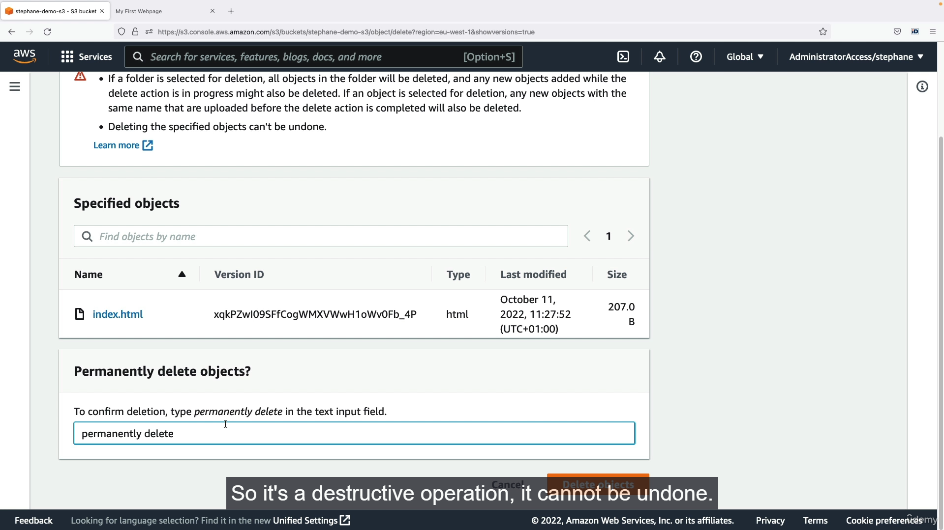

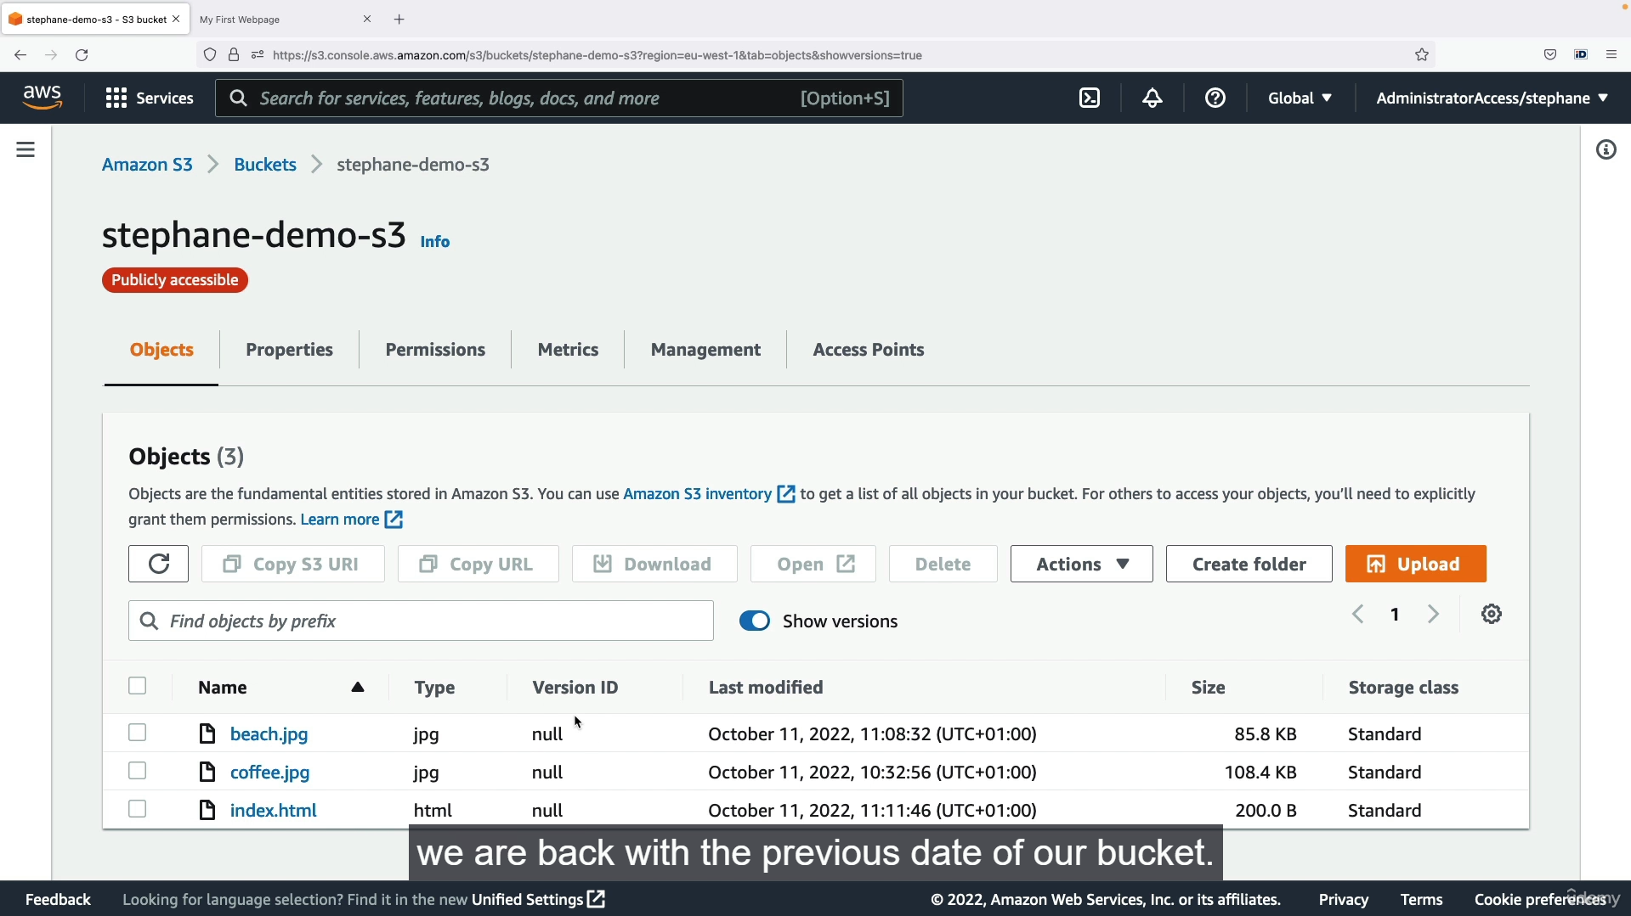

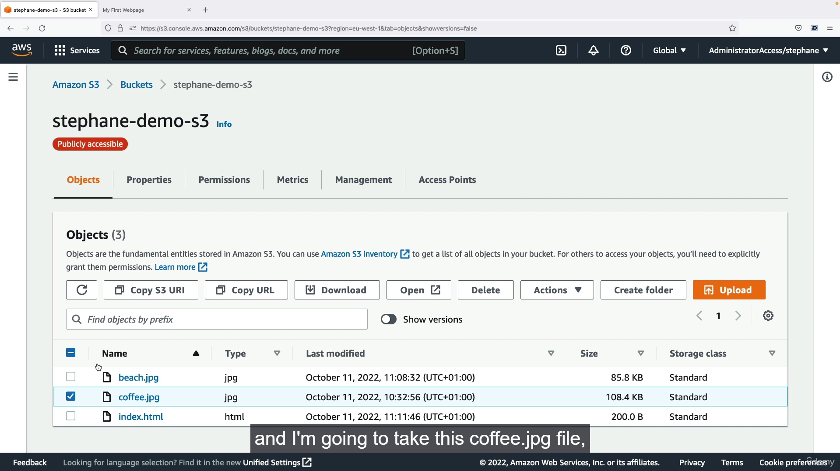

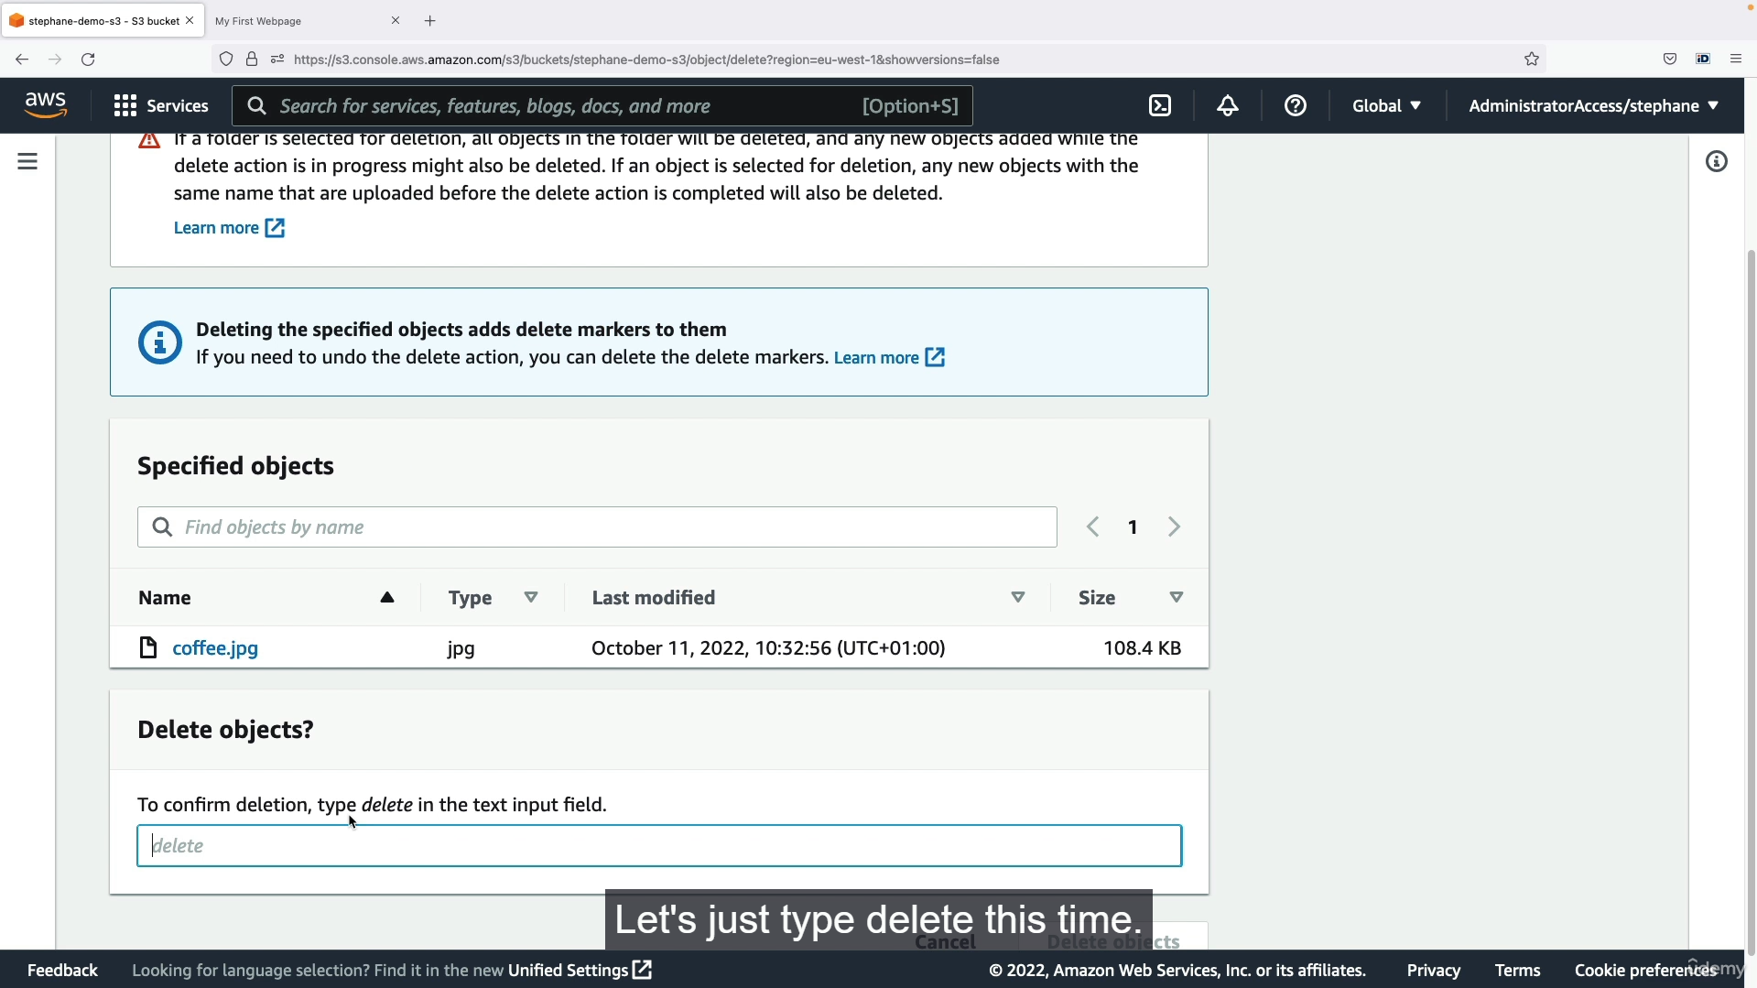

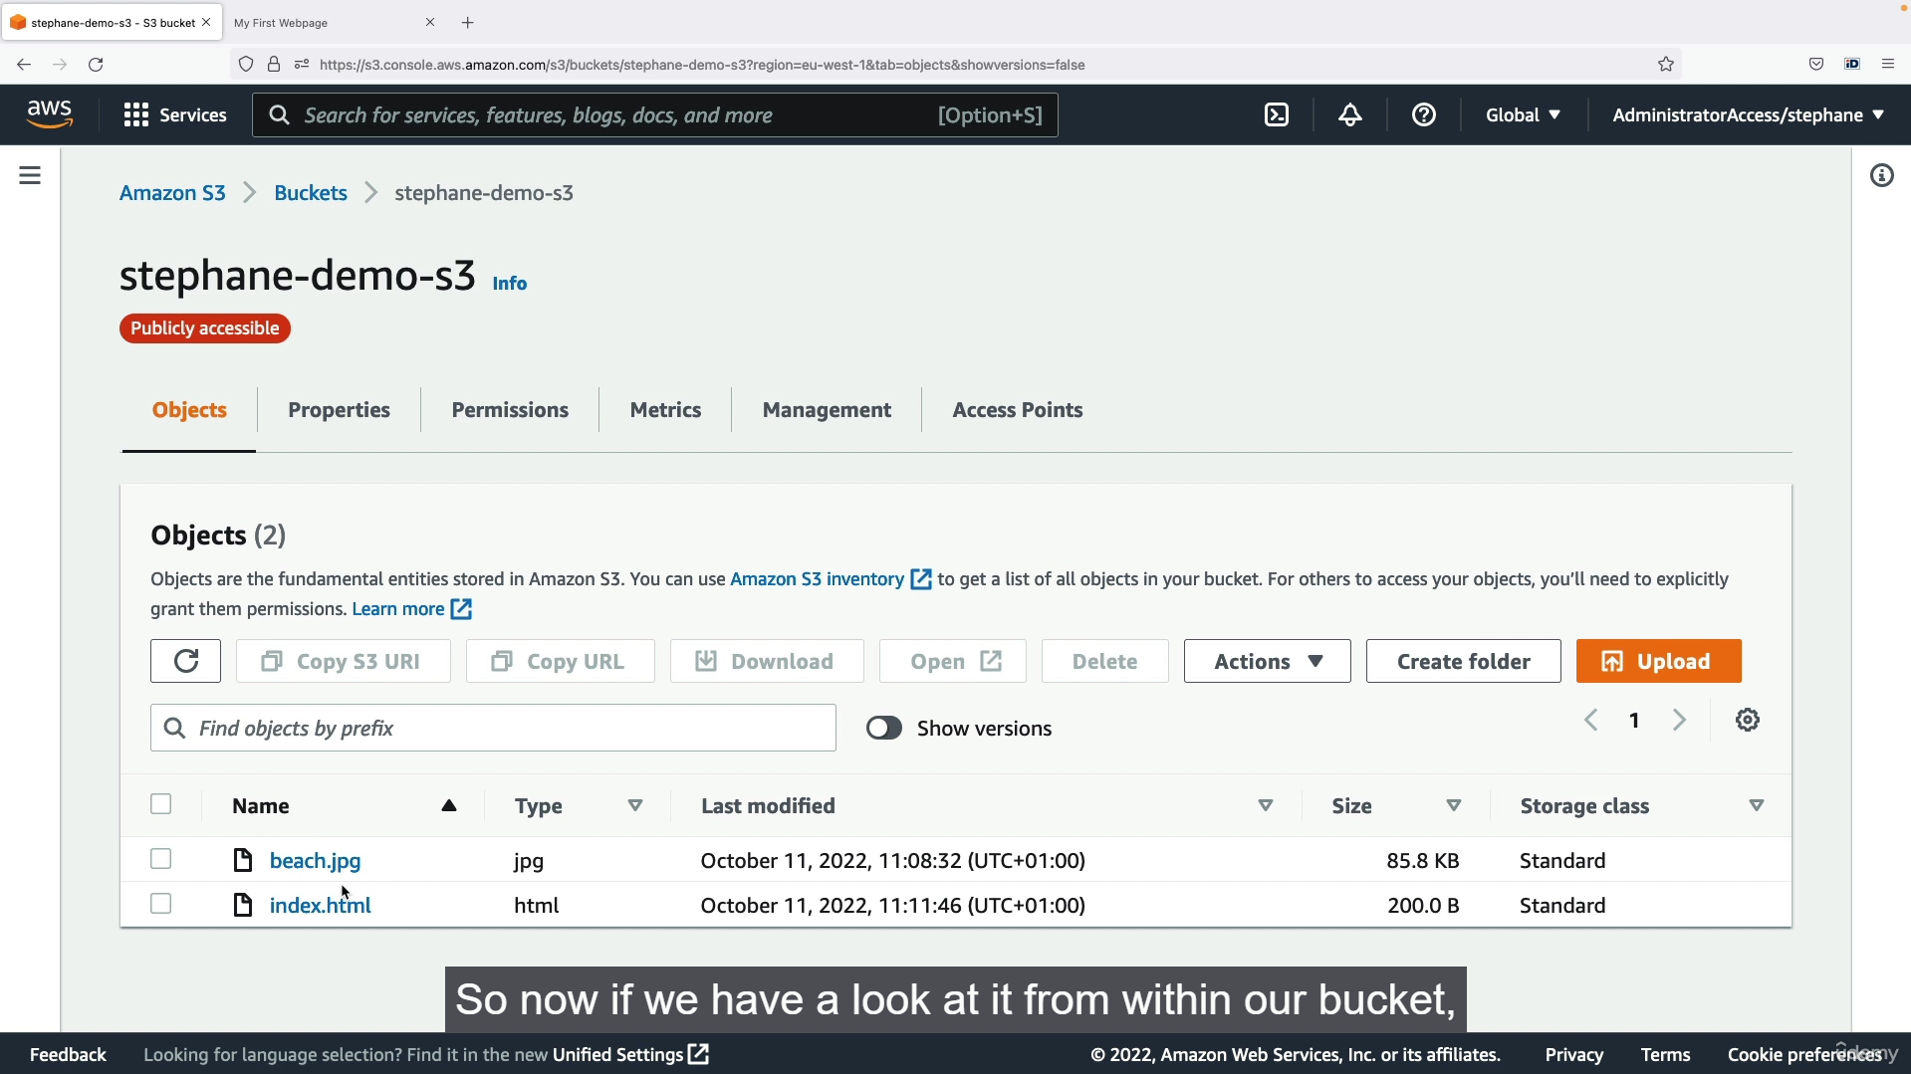

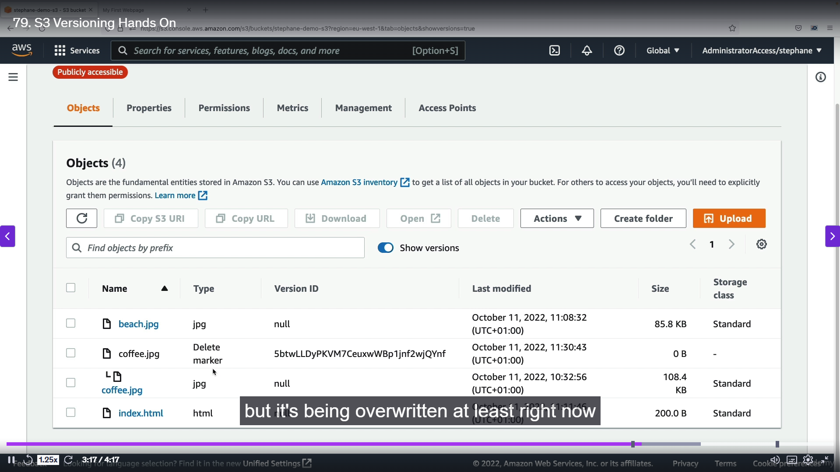

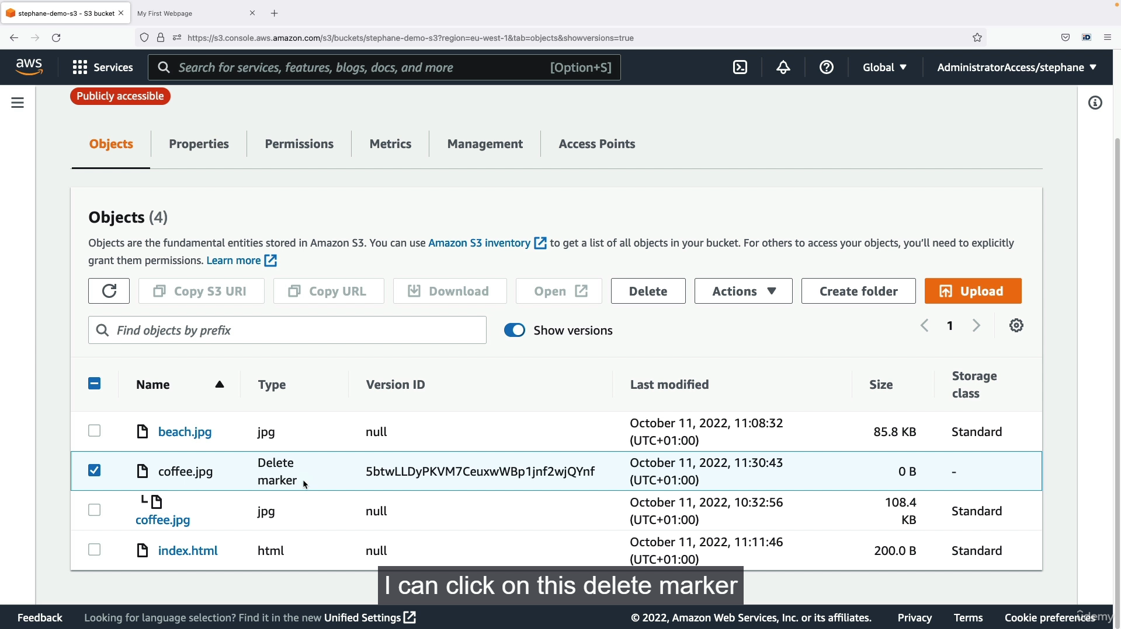

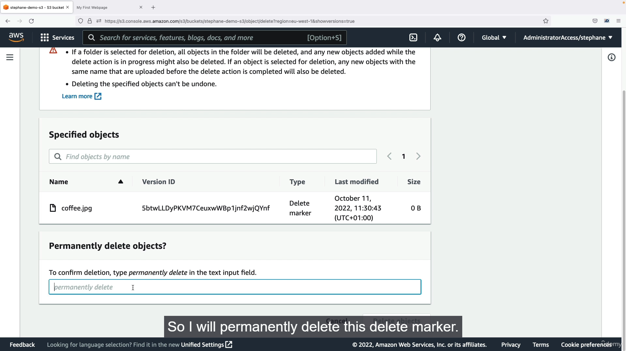

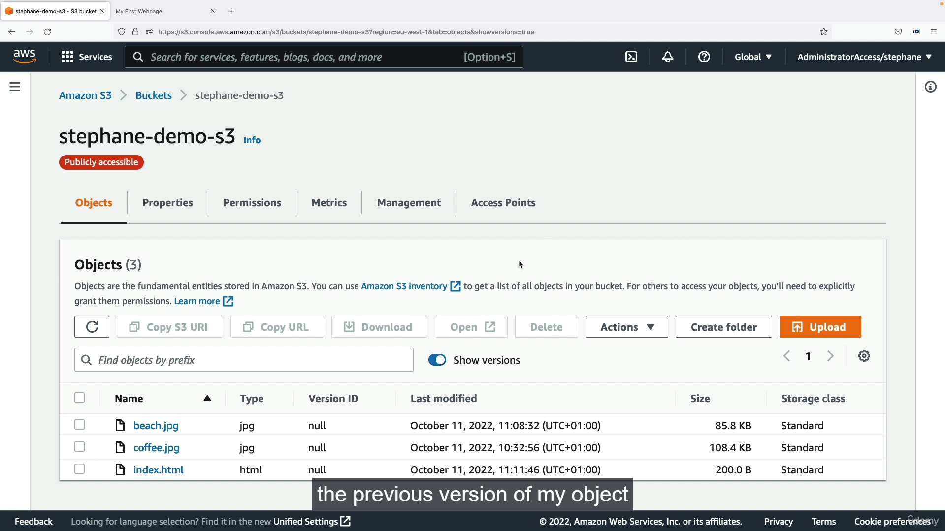

**Step-by-Step Guide to AWS S3 Versioning**

**Part 1: Enabling Versioning and Overwriting an Object**

1. **Enable Versioning:** Go to the S3 bucket's "Properties" tab, find "Bucket Versioning," and click "Edit." Enable versioning and save the changes. This setting allows AWS to keep previous versions of an object when it is overwritten.
2. **Edit the Object:** Locate the object you want to update (e.g., index.html). Edit the content of the file locally (e.g., changing "I love coffee" to "I really love coffee").
3. **Upload the New Version:** Upload the updated file (index.html) back to the same S3 bucket. AWS will now treat this as a new version, but it will not overwrite the previous version. The new content will be the one served to users.
4. **View Object Versions:** To see all versions of your objects, toggle the "Show versions" button in the S3 bucket's "Objects" tab. You will notice that:
   * Objects uploaded before versioning was enabled have a "null" Version ID.
   * The first version of an object uploaded after versioning is enabled will have a unique Version ID.
   * The newly uploaded file will have its own unique Version ID, while the old version will still exist with its "null" Version ID.

**Part 2: Rolling Back to a Previous Version**

1. **Permanent Delete:** To roll back to an older version of a file, locate the version you want to remove (the most recent one in this case) while "Show versions" is enabled. Click the checkbox next to the specific version ID and select "Delete." You must type "permanently delete" in the confirmation box to remove that specific version.
   * **Note:** This is a permanent and destructive action that cannot be undone.
2. **Result:** Once the latest version is permanently deleted, the previous version of the object becomes the current one. Refreshing the webpage will show the old content (e.g., "I love coffee").

**Part 3: Deleting an Object and Using a Delete Marker**

1. **Disable "Show Versions":** First, turn off the "Show versions" toggle.
2. **Delete the Object:** Select an object (e.g., coffee.jpg) and click "Delete." Type "delete" (not "permanently delete") in the confirmation box.
3. **Result:** From the default view, the object appears to be gone. The webpage will show a "404 Not Found" error for the image. However, the underlying object is not truly deleted.
4. **View Delete Marker:** Turn the "Show versions" toggle back on. You will see the original object with its Version ID, and a "Delete Marker" with a new Version ID. The delete marker acts as the most recent version, effectively hiding the object from public view.

**Part 4: Restoring a Deleted Object**

1. **Delete the Delete Marker:** To restore the object, find the "Delete Marker" while "Show versions" is enabled. Select it and click "Delete." You must type "permanently delete" in the confirmation box to remove the delete marker.
2. **Result:** Deleting the delete marker makes the previous version of the object visible and active again. Refreshing the webpage will show the restored image.